Notes form Jubileum Residents Meeting
Date: 5 October 2024
Venue: Jubileum Street.
- Reservoir, Escort, Jubileum, River
  - Flooding in the area due to stormwater
  - Road Stormwater issues area in Yellow
  - Consent needed from erf 1361
1 white – Stormwater trench to be dug to assist with water flow
2 blue – Concrete drainage channel
3 red – road repair
4 green – stormwater sloot
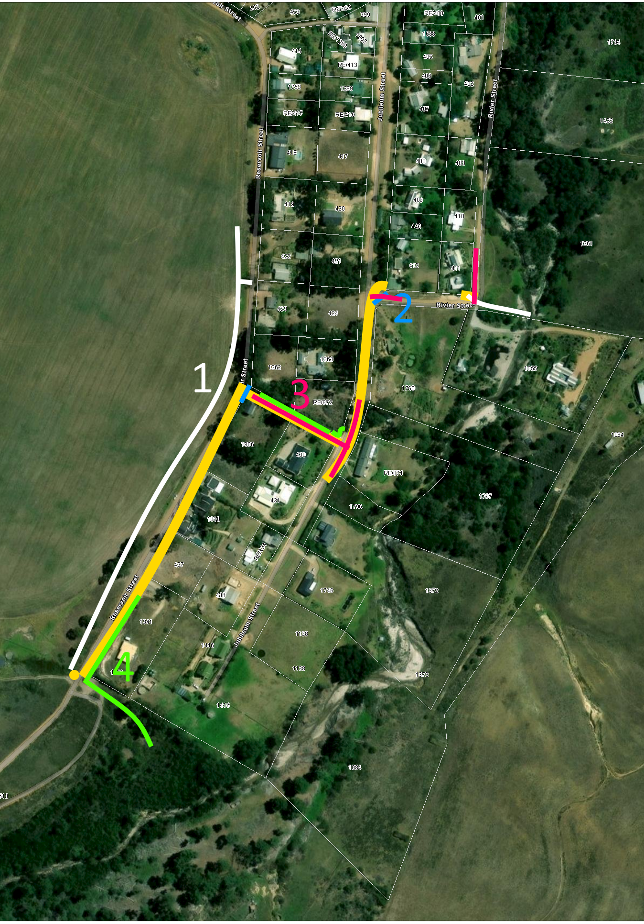

- Jubileum
  - Flooding in the area due to stormwater
  - Road Stormwater issues area in Yellow
  - Consent needed from erf 389
1 white – Stormwater trench to be dug to assist with water flow
2 blue – Concrete drainage channel
3 red – road repair
4 green – pipe over lay water
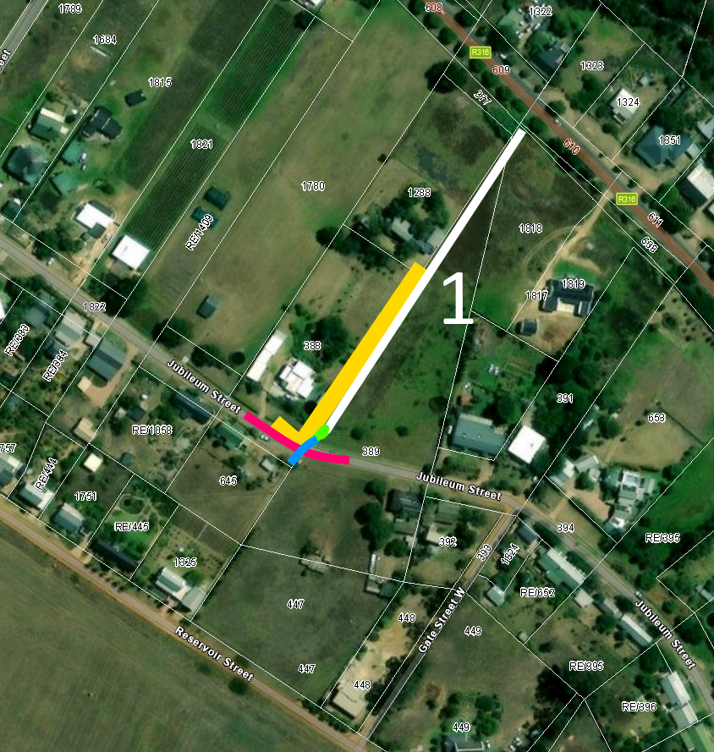

- Greed in meeting
  - Work will commence 6 November
  - Trenchers will commence 6 November
  - Deon Wasserman will get consent from owners where needed
  - Dates of other work to be provided as soon as possible.

- Other roads identified in the broader Napier
  - Trenchers need to be done at same time while digger in Napier for Pine Road and others if needed.
