Ward 1 -Ward Committee Meeting
11 March 2025
Elim Overseers Council Hall at 18:00
- WELCOME
Councillor Ross welcomes all ward committee members present.
RR requested that KP take minutes of the meeting.
- ATTENDANCE & APPLICATIONS FOR LEAVE OF ABSENCE
Apologies: Jose de Kock (JdK), Caitlin Leonard (CL),
Absent without apology: Sakhile Mlati (SM)
Attendance: Rdl Raymond Ross (RR), Ivan Boshoff (IB), Hilary Mellet (HM), Mark Partington (MP), Kevin Poulter (KP), Kent Georgala (KG), Aron van Breda (AvB), Philana Bruinfies (PB), Okko de Jamaer (OdK),
Attendance Register Attached
- OPENING READING AND PRAYER
  - AvB did the reading and prayer – Matthew 19 vs 26
- MINUTES OF PREVIOUS MEETING
Minutes to be amended with corrections from IB and KP. KP will amend the minutes and circulate to ward committee members.
Minutes are proposed by Ivan Boshoff and accepted by Hilary Mellet.
- MATTERS ARISING FROM PREVIOUS MINUTES
  - Spanjaardskloof Residents feedback.
    - Roads needs to be scraped under the responsibility of ODM
    - Wifi- TDK needs to be involved regarding the wifi
    - Water- RR to address with Director of Infrastructure and Manager of Water
- NEW MATTERS
  - Public Participation on Heritage Strategies – Deadline 8 April
  - Public Participation on street naming and public place naming
    - Two street names have been renamed with no impact on businesses or residential address. There is no policy in place with regards renaming of streets and an application that would effect businesses and residential needs to be considered.
- REPORT BACK FROM STAKEHOLDERS
  - Napier Residents Association
    - Outstanding land use application with no decision to be cancelled or extension time to be given with a final deadline and if no decision cancelled. Meeting was in agreement. (Motivation provided Annexure A)
    - Festival application outstanding and should be cancelled. RR indicated that it was approved by council. KP indicated that the minutes of council meeting indicated that the Event was approved but not the Land Use Application. RR to follow-up. If approved CAM are in default with regards notifying interested and effected parties. Annexure B – Minutes of Council Meeting.
    - Availability of Minutes of ward committee meetings within 14 days. (Agreed)
    - KP questioned decision made at municipal council meeting 27 March 2025 regarding Agenda for Council meetings.
Die Speaker noem dat hy versoeke vanaf die publiek ontvang het om Raadsagendas te bekom. ‘n Konsensusbesluit is geneem deur die Raad dat Raadsagendas (sonder die In-Komitee gedeelte) na goedkeuring, op die webtuise geplaas word deur die Kommunikasie-departement. Inwoners sal dan toegang he om die agendas af te laai.
RR indicated that the agenda would be made available before the council meetings on the municipal website. KP indicated this was not the communication. Annexure C.
    - Notice of Council meetings. KP indicated that there has been no public notice for council meetings during 2025. No notice in local newspapers, website, Facebook or municipal office in Napier. KP also indicated that there has only been 1 minutes of meetings published of the 3 council meetings held this year. RR to follow-up.
    - Reports of disturbances, public intoxication, and reckless driving around Tex Bottle Store, particularly on weekends.
Law enforcement does not operate on weekends, allowing issues to persist unchecked.
Private security attempts to intervene but cannot enforce municipal bylaws.
There is concern that police claim this is not their responsibility, leaving a legal enforcement gap.
Traffic to be involved to address driving under the influence.
Decisions Made:
      - A site visit will be conducted on Sunday morning to assess the situation firsthand.
      - A formal complaint will be escalated to the Municipal Manager and the Police Commissioner.
    - RDP Housing
The committee expressed concerns over ongoing delays in the RDP housing project. Despite previous commitments from the municipality and allocated funding, construction has yet to commence, and there is a lack of clear communication from the Department of Infrastructure on project timelines. Key points raised during the discussion:
ASLA Contract: The primary delay due to Auditor General report relating to contract.
Delays in Tender Process: Although contractors were expected to be appointed, no confirmed start dates have been provided.
Community Frustration: Residents who have been waiting for housing allocation have received no official updates on when construction will begin.
Provincial Government: The contract will now fall under provincial government and was approved at the last council meeting. The project now awaits contracts signed between ASLA and Provincial Government before timeframes can be given.
Housing Projects: The proposed housing projects for Napier and Struisbaai will be included.
  - Huis Klipperdrif
    - No items raised as already dealt with.
  - CARBA
    - Play Park
The committee supports the establishment of new playgrounds in secure locations.
Private sponsors may be approached for additional funding and equipment. It was proposed to look at another location for this either near the informal settlement or at Protea school.
    - Bridges: The construction tender has closed, and work is expected to start in April. Annexure D last formal communication on process.
  - Napier CPF
    - Elections and Security Updates
96% of CPF elections have been completed in the Western Cape.
Overberg CPF elections are scheduled for 11 April.
IB to provide a post-election report at the next meeting
  - Napier Heritage and Conservation Body
    - NHCB to be in contact Nomfundo Tofu with regarding the fencing for the graveyard.
    - Dips in power was highlighted as a concern in Napier and wondered if this is maybe a pumpstation switching on. CAM to investigate.
  - Neighbourhood Watch
    - Need for structured training for Neighbourhood Watch (NW) and Street Watch volunteers.
    - Proposal: Organize a workshop with SAPS, CPF, and law enforcement trainers.
    - Training proposed date 22 March. Confirmation of date to be sent to RR.
  - Spanjaardskloof
    - Addressed in matters arising
  - Elim
    - Church feels that CAM should only charge them for Rates and Taxes on Farm but not for Elim itself.
    - This is based on the historical value of the old part of Elim. There are now modern houses now been built.
    - CPW workers needed for Elim from April
    - CAM to visit Elim house shops with regards licenses
Process is not working as ODM Health and Safety are approving but applications via CAM are not being done. Follow up with Sisonke Simelane from ODM.
    - Gravel needed for some of the roads and request CAM to provide.
  - Informal Area
    - SM no longer coming to ward meetings and does not seem to be living in the area. Another member of the community should be attending. Letter from informal settlement committee to this effect to be provided.
    - Informal settlement started a process of trying to clean the area themselves. We will see how this will progress.

- COMMUNITY CORRISPONDANCE
  - Napier Market and the use of Grobbelaar Hall. RR to follow up on status of contract with CAM and Kingdom Ambassador.
- GERNERAL MATTERS AND ADDITIONAL ITEMS
  - Discussion was had around outstanding rates accounts. It was noted that some businesses and individuals owe significant amounts in unpaid rates, yet small residents face electricity cutoffs for minor arrears. A question was raised around the Sarel Cilliers and High Street development and the payment of rates. It was requested that this be followed up. It was noted that the Credit Control and Debt Collection policy May 2024 needs to be reviewed relating to header: MASAKHANE BELEID and related text.
  - Discussion was had around infrastructure needs for Cape Agulhas which is being discussed for the future needs of CAM. Water, Electricity, Sewerage and Roads. RR provided feedback.
- CLOSING REMARKS AND NEXT MEETING
The chairperson thanked all participants for their contributions. The next meeting is scheduled for 8 April 2025 at 18:00 in Napier.
Meeting closed at 19:19

ACTIONS AND RESPONSIBILITIES – Ward 1 Cape Agulhas Municipality
DATE ADDED | ACTION AND FEEDBACK | RESPONSABLITY | CAM/ODM | BY WHEN
11/02/25 | Spanjaardskloof: Roads scraping under the responsibility of ODM. To be address with councillor from ODM. | RR | Johan Nieuwoudt
11/02/25 | Spanjaardskloof: municipal water issues to be resolved | RR | Brian Neale
11/02/25 | Spanjaardskloof: wifi to be resolved
11/02/25 | Speed cameras and traffic calming measures in Napier | RR
11/02/25 | Follow up with municipal officials on outstanding repairs regarding Roads and Stormwater | RR
11/02/25 | Raymond Ross committed to attending the monthly NRA meeting for the first Tuesday of every month. | RR
11/02/25 | Heritage strategy for public participation | All |  | 07/04/25
11/02/25 | Caitlin to find out how many students did not get placed in a High School within Cape Agulhas. | RR
11/03/25 | Public Participation on street naming and public place naming | All |  | 07/04/25
11/03/25 | Outstanding Land use application to be cancelled if no outcomes. (3.a.i) | RR | Sunel Nel | 21/03/25
11/03/25 | Festival Application for Land Use. Was this approved? (3.a.ii) | RR | Sunel Nel | 21/03/25
11/03/25 | Council meetings. Notices and Minutes not being published (3.a.v) | RR | Ebin Philips | 21/03/25
11/03/25 | Committee Members to conduct a Sunday morning site visit at 10am (3.a.vi) | RR, MP, All |  | 16/03/25
11/02/25  11/03/25 | Cilr Ross and Ivan had a meeting with Mr Texeira regarding complaints about the liquor store, no complaints were received since.  Tex Bottle Store complaints to be escalate to the Municipal Manager and the Police Commissioner (3.a.vi) | RR | Ebin Philips,  Captain Ross | 21/03/25
11/03/25 | CPF provide a post-election report at the next meeting (8.d.i) | IB |  | 08/04/25
11/03/25 | NHCB to be in contact Nomfundo Tofu with regarding the fencing for the graveyard. | OdK
11/03/25 | Dips in power was highlighted as a concern in Napier and wondered if this is maybe a pumpstation switching on. CAM to investigate | RR
11/03/25 | Feedback on when Neighbourhood watch training will take place to RR (8.f.iii) | HM
11/03/25 | CAM to visit Elim house shops with regards licenses and to follow up with Sisonke Simelane from ODM. (8.h.iv) | RR | Sunel Nel,  Sisonke Simelane | 28/03/25
11/03/25 | Letter from informal settlement committee to this effect to be provided to remove SM from the Ward Committee and appoint new member. (8.i.i) | KP |  | 21/03/25
11/02/25  11/03/25 | Grobbelaar Hall Rental. Feedback status of contract with CAM and Kingdom Ambassador.  Follow-up in light of Napier Market wanting to use (9.a) | RR | Paul Valentine | 21/03/25
11/03/25 | Outstanding rates on accounts needs to be addressed and specifically with regards developers | RR | Werner Jonker | 21/03/25

Contents
Annexure A 8
Annexure B 11
Annexure C 16
Annexure D 17
Attendance Register 18
Draft Agenda 19

Annexure A
Motivation: Outstanding land use application with no decision

The NRA, representing the interests of residents within the Cape Agulhas municipal area, hereby submits this motivation to propose an amendment to the Cape Agulhas By-law on Municipal Land Use Planning, 2022 (published in the Province of the Western Cape: Provincial Gazette Extraordinary 8632 on 15 July 2022). We request the introduction of a provision to automatically cancel any land use application—such as applications for departures, rezonings, or subdivisions—that remains outstanding with no decision or action by the Municipality for more than 120 days following the completion of the application process. Our proposal addresses critical issues of administrative oversight, community impact, and the relevance of outdated applications in light of changing circumstances.
Background and Current Framework
The by-law, aligned with the Spatial Planning and Land Use Management Act, 2013 (Act 16 of 2013) (SPLUMA) and its Regulations (Regulation 16), stipulates that the Municipality should decide on a complete application within 120 days (Section 57 - "Decision-making period"). If no decision is made, Section 58 ("Failure to act within period") permits the applicant to appeal to the Appeal Authority within 21 days (Section 80). However, without a decision or appeal, applications can remain pending indefinitely. This creates a gap that our community finds increasingly problematic, as outlined below.
Motivation for the Proposed Amendment
- Risk of Applications Slipping Through Unnoticed
  - Prolonged delays beyond 120 days result in applications fading from active oversight. With no mandatory resolution mechanism, these applications can "slip through the cracks," escaping the attention of municipal officials, residents, and stakeholders who initially monitored them. For instance, a rezoning application pending for years might proceed unnoticed if eventually decided, bypassing updated scrutiny or public input required under Section 45 ("Publication of notices"). Automatic cancellation after 120 days would ensure that only actively monitored and current applications remain in the system, reducing the risk of unchecked decisions.
- Changing Circumstances Rendering Applications Obsolete
  - Circumstances surrounding land use applications—such as environmental conditions, infrastructure capacity, community needs, or economic feasibility—can change significantly over time. An application submitted years ago (e.g., a subdivision plan reliant on outdated traffic assumptions) may no longer be viable or appropriate today. The by-law’s silence on indefinite pendency fails to account for this, potentially allowing approvals that conflict with current realities. Cancelling applications after 120 days ensures that only proposals reflecting present conditions are considered, requiring applicants to resubmit updated plans if necessary.
- Promoting Administrative Efficiency and Accountability
  - Indefinitely pending applications strain municipal resources, creating backlogs that hinder efficient planning. Without a cancellation mechanism, the Municipality is not compelled to resolve delays, undermining accountability. A 120-day cancellation rule would enforce timely decision-making, aligning with SPLUMA’s intent and freeing capacity for new, relevant proposals.
- Protecting Community Interests and Certainty
  - Residents rely on timely decisions to anticipate changes to their environment. An application stalled for years—such as a departure affecting neighbourhood aesthetics—leaves communities in limbo, impacting property values and planning. Worse, if eventually approved without renewed consultation, it could surprise residents who assumed it had lapsed. Cancellation after 120 days provides closure, ensuring that any revived proposal undergoes fresh public participation (Section 44) to reflect current community views.
- Preventing System Abuse
  - The lack of a deadline could allow applicants to submit speculative proposals, leaving them pending without follow-through, tying up municipal processes. Automatic cancellation discourages this by requiring active pursuit within 120 days, ensuring the system prioritizes serious, feasible applications.
Proposed Amendment
We propose adding a new subsection under Section 58 ("Failure to act within period") as follows:
"Section 58(2) – Automatic Cancellation of Applications
If the Municipality fails to make a decision on an application within 120 days from the date the application is deemed complete, as contemplated in Section 57, and no appeal has been lodged by the applicant in terms of Section 80 within 21 days thereafter, the application shall be deemed cancelled. The Municipality must notify the applicant in writing of such cancellation within 14 days of the cancellation date and record the cancellation in its register. The applicant may resubmit the application anew if desired, subject to the provisions of this By-law, including updated documentation reflecting current circumstances."**
Implementation Considerations
- Oversight Mechanism: The Municipality should track applications via a public register, flagging those nearing 120 days to prevent oversight lapses.
- Grace Period: The 21-day appeal window post-120 days ensures fairness, allowing applicants a final chance to act before cancellation.
- Resubmission Requirement: Requiring updated submissions ensures that revived applications address current conditions, maintaining relevance.
- Public Notification: Cancellation notices should be accessible to residents (e.g., via the Municipal website), enhancing transparency.
Benefits to the Community and Municipality
- For Residents: Mitigates risks of outdated or unnoticed approvals, ensuring community input remains relevant and developments suit current needs.
- For Applicants: Encourages timely engagement, filtering out unfeasible proposals while allowing fresh submissions when conditions improve.
- For the Municipality: Reduces backlog, enhances oversight, and aligns with adaptive, responsive governance.
Conclusion
The NRA is deeply concerned that applications outstanding beyond 120 days can slip through unnoticed and may no longer be feasible due to changed circumstances. This jeopardizes community trust and effective planning. By amending the by-law to cancel such applications automatically, the Cape Agulhas Municipality can safeguard oversight, ensure relevance, and uphold its commitment to orderly land use management. We urge consideration of this proposal in the next by-law review or as an urgent amendment, with public consultation per Section 99 ("Repeal and Transitional Arrangements"). We welcome further discussion to refine this solution.

Annexure B
Extract of Council Minutes 28 January 2025
8.3 APPLICATION FOR AN EVENT: SMALL TOWN BEAT NAPIER

REPORT FROM : DIVISION HEAD: STRATEGIC PLANNING AND ADMINISTRATION PURPOSE OF REPORT
For Council to consider an application for an event known as the Small Town Beat Music Festival on the privately owned Vadersberg Guest and Adventure Farm outside Napier from 14 to 16 February 2025.
The application is submitted to Council for consideration as the new events committee envisaged by the policy approved in December 2024 has not been formally appointed and no clear terms of reference exist in respect of the previous one that guide how an appeal must be handled when an event is declined.

If handled in terms of Section 62 of the Municipal Systems Act appeal process, it will in any event need to be considered by the Council, as the original decision letter was issued by the Municipal Manager. Under normal circumstances the Executive Mayor would be the appeal authority in respect of a decision taken by the Municipal Manager but in this case the Executive Mayor was part of the decision making process in his role as Ward Councillor and cannot consider the appeal.

BACKGROUND

An application was received from Honey Badger Consultant for an event known as the Small Town Beat Music Festival was received on 20 November 2024. (This was prior to the approval of the new events policy). The same event took place in February 2024.

The application was considered by the Events Committee on 17 December 2024, where it was resolved as follows:

Upon review of the minutes of the event applications, it has been determined that the application for the “Small Town Beat” event has been declined. This decision was made based on the following concerns raised from the previous year’s events:

1. Noise pollution affecting the surrounding areas.
2. High volumes of alcohol consumption.
3. Livestock is being disturbed by the extreme noise levels.
4. Presence of drugs being brought into the events.
5. SAPS received twenty-five complaints regarding the noise.

On 23 December 2024 the applicant was informed that the application was declined and provided with the following reasons:

a) Complaints about noise pollution. b) Influx of drugs to the event site.
c) Misuse of alcohol.

The decision letter is attached as Annexure A.

A letter of appeal was received on 24 December 2024 and is attached as Annexure B.

The grounds of appeal are:

a) They were not given an opportunity to engage with the committee.
b) The concern relating to noise was acknowledged, but they reiterated that stringent control measures will be implemented as per their Noise Management Plan.
c) They contend that SAPS previously held a successful roadblock and made multiple arrests, and that
SAPS and Law Enforcement made visits to the site.
d) They contend that the misuse of alcohol is vague and baseless and cannot be applied as a valid reason to decline the event as misuse of alcohol happens in bars in Napier all the time and there are
no reports of how it can be correlated to the event
e) Furthermore, they contend that a considerable amount of money has already been spent on the event they are actively engaging with local farmers to address any concerns.

As the offices closed on this date, no further action was taken until the offices re-opened in January 2025.

A further letter was received from Booth Attorneys who were acting on their behalf on17 January 2025 which is attached as Annexure C.

They contend that in the absence of a by-law the municipality has no jurisdiction to make a decision on the approval or decline of an event. They furthermore state that they intend to hold the event and will approach a competent court to enforce their rights.

Booth Attorneys are correct in stating that the By-Law that was considered by Council on
12 December 2024 is of no force as it is not promulgated. However, this does not derogate from Council's rights to make a decision in this regard. The Safety and Sports and Recreational Events Act, 2010 (Act No.
2 of 2010) and regulations apply as well as the provisions of various By-Laws.

Furthermore, the Provincial Operational Coordinator Centre of SAPS issued a risk grading to the event organisers which is referred to in paragraph 23 of their letter where it specifically states that:

“5. The lo cal authority mus t i ss ue an ev ent permi t before the ev ent may c onti nue. Without the ev ent permi t
issued by the local authority, the event may not be hosted. The event permit issued as such may also
s ti pulate mandatory condi tio ns”

It is therefore clear that the Municipality’s approval is required to host the event.

The remainder of the letter deals with factors related to the event which were re-considered by the events committee on 20 January 2025. The outcomes of the meeting are below. The recommendation is that permission be granted for the continuation of the event subject to additional conditions to ensure that the concerns of various role players are considered.

ITEM | SMALL TOWN BEAT
DISCUSSION OUTCOME/S | ACTION REQUIRED
An appeal application was submitted.  After the “Small Town Beat” event received a letter from the events committee that their event was declined.  This decision was based on the following concerns raised from the previous year’s events.  1. Noise pollution affecting the surrounding areas.  2. High volumes of alcohol consumption.  3. Livestock is being disturbed by the extreme noise levels.  4. Presence of drugs being brought into the events.  5. SAPS received twenty-five complaints  regarding the noise. | It was essential to take swift and strategic action to mitigate its impact if the event went ahead.  After careful deliberation, all the stakeholders decided that the event may go under very strict conditions set by SAPS and the ODM Fire and Rescue in conjunction with CAM.  That SAPS and all other law enforcement agencies be provided with 24 hour access to the premises.  That no music be permitted between 22:00 until 8:00  That no illegal substances be allowed.  It is therefore recommended that the event permit be issued to Honey Badger Consultant to hold the Small Town Beat Music Festival at Vadersberg Guest and Adventure Farm from 14-16  February 2025 subject to the following conditions:  That the stipulations of all plans submitted as part of the application be strictly adhered to.  That the requirements of ODM be adhered to in respect of the following:  • 2 x 600L equipped skid units  • 2 x Portable Pumps and suction hose  • 11 x Fire crew  • 1 x 3000 l Fire Tanker  • One Helicopter two hours flight time MOU signed and approved.  • Additional emergency exits  • Other smaller items and rules as per regulations like fire extinguishers etc.

ODM and SAPS Napier were requested to provide written submissions which are attached as Annexures D and E. Napier SAPS recommend that the original decision of the events committee be upheld, based on their experience with the 2024 festival, whilst ODM recommended additional measures to be put in place.

To be noted that there is also a Town Planning application submitted for a consent use for purposes of five self-catering guest accommodation houses and a departure for occasional use, to utilise a portion of the farm for an annual music festival. Objections were received to the departure use component of the application. The events application and Town Planning application must not be confused as the event application is for a single event whereas the Town Planning application is for a permanent right to host such events. Town Planning will not consider this part of the application as each event needs to be considered individually by the events committee.

It is therefore recommended that an events permit be issued to Honey Badger Consultant to hold the Small Town Beat Music Festival at Vadersberg Guest and Adventure Farm from 14 - 16 February 2025 subject to the following conditions:

(i) That the stipulations of all plans submitted as part of the application be strictly adhered to. (ii) That the requirements of ODM be adhered to in respect of the following:
a. 2 x 600L equipped skid units
b. 2 x Portable Pumps and suction hose c. 11 x Fire crew
d. 1 x 3000 l Fire Tanker
e. One Helicopter two hours flight time MOU signed and approved. f. Additional emergency exits
g. Other smaller items and rules as per regulations like fire extinguishers etc.
(iii) That SAPS and all other law enforcement agencies be provided with 24-hour access to the premises. (v) That no music be permitted between 22:00 until 8:00.
(vi) That no illegal substances be allowed.

LEGAL FRAMEWORK

1. Safety and Sports and Recreational Events Act, 2010 (Act No. 2 of 2010)
2. Various By-Laws

FINANCIAL IMPLICATIONS

Overtime for Law Enforcement Officials.

COMMENTS FROM THE DIRECTOR MANAGEMENT SERVICES

In order for Council to make an informed decision, it is important for SAPS Napier to submit their report of
the previous year’s event.

MANAGEMENT RECOMMENDATION

1. That an event permit be issued to Honey Badger Consultant to hold the Small Town Beat Music Festival at Vadersberg Guest and Adventure Farm from 14 -16 February 2025 subject to the following conditions:
2. That the stipulations of all plans submitted as part of the application be strictly adhered to.
3. That the requirements of the ODM be adhered to in respect of the following:
a. 2 x 600L equipped skid units
b. 2 x Portable Pumps and suction hose c. 11 x Fire crew
d. 1 x 3 000L Fire Tanker
e. One Helicopter two hours flight time MOU signed and approved. f. Additional emergency exits
g. Other smaller items and rules as per regulations like fire extinguishers etc as approved by ODM.

4. That SAPS and all other law enforcement agencies be provided with 24 hour access to the premises.
5. That no music be permitted between 22:00 until 8:00
6. That no illegal substances be allowed.

(Councillor Ross is not present during discussion of the matter.)

RESOLUTION 9/2025

1. That an event permit be issued to Honey Badger Consultant to hold the Small Town Beat Music Festival at Vadersberg Guest and Adventure Farm from 14 -16 February 2025 subject to the following conditions:
2. That the stipulations of all plans submitted as part of the application be strictly adhered to.
3. That the requirements of the ODM be adhered to in respect of the following:
a. 2 x 600L equipped skid units
b. 2 x Portable Pumps and suction hose c. 11 x Fire crew
d. 1 x 3 000L Fire Tanker
e. One Helicopter two hours flight time MOU signed and approved. f. Additional emergency exits
g. Other smaller items and rules as per regulations like fire extinguishers etc as approved by ODM.
4. That SAPS and all other law enforcement agencies be provided with 24 hour access to the premises.
5. That no music be permitted between 22:00 until 8:00
6. That no illegal substances be allowed.

Implementation: Strategic Planning and Administration

Annexure C
Notes provided from Council Meeting:
The Speaker mentions that he has received requests from the public to obtain Council agendas. A consensus decision was made by the Council that Council agendas (excluding the In-Committee section) will be published on the website by the Communications Department after approval. Residents will then have access to download the agendas.
Comments:
Currently there is a process of acceptance of agenda towards the beginning of Council meetings which could be interpreted as the approval of the agenda.

Annexure D
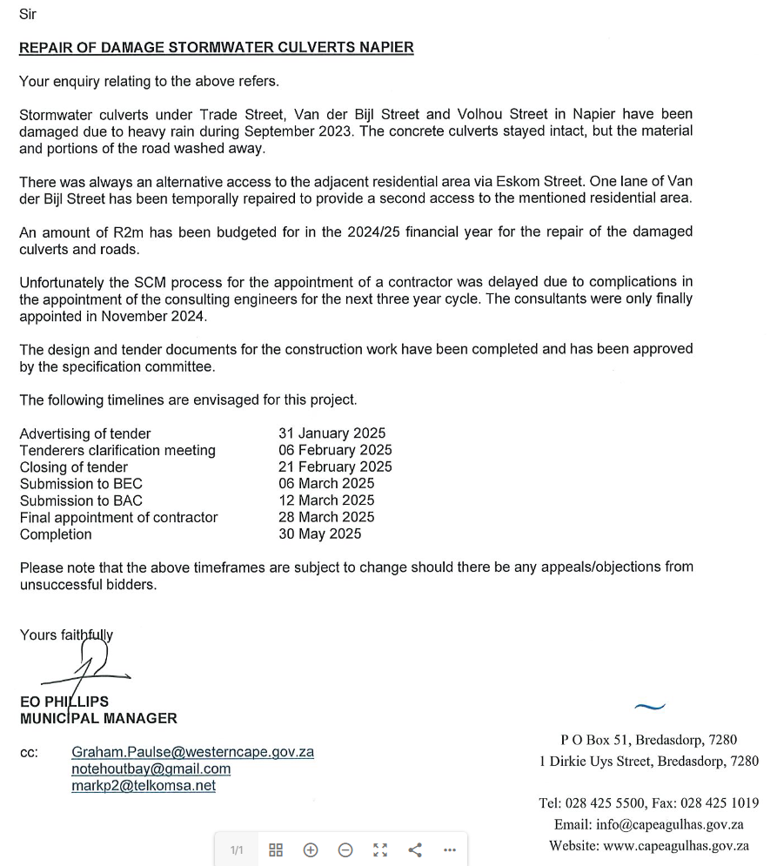

Attendance Register
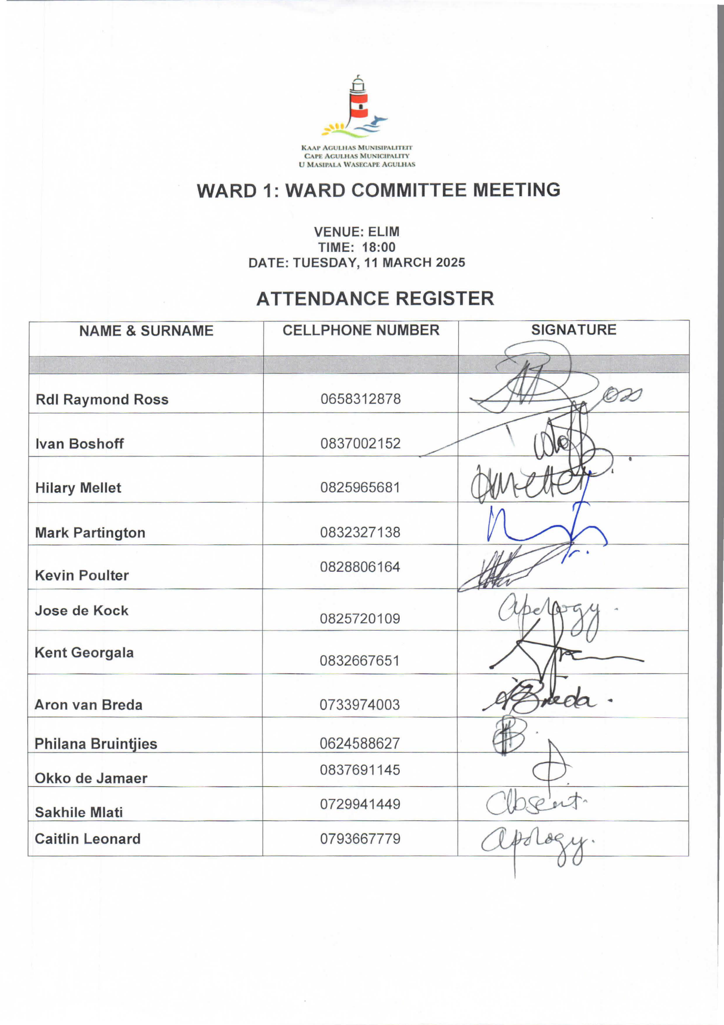

Draft Agenda
Ward 1 -Ward Committee Meeting
8 April 2025
Napier Municipal Office at 18:00
- WELCOME
Councillor Ross welcomes all ward committee members present.
- ATTENDANCE I APPLICATIONS FOR LEAVE OF ABSENCE
Apologies:
Absent without apology:
Attendance: Rdl Raymond Ross (RR), Ivan Boshoff (IB), Hilary Mellet (HM), Mark Partington (MP), Kevin Poulter (KP), Kent Georgala (KG), Aron van Breda (AvB), Philana Bruinfies (PB), Okko de Jamaer (OdK), Jose de Kock (JdK), Caitlin Leonard (CL), Informal Settlement
- OPENING READING AND PRAYER
- MINUTES OF PREVIOUS MEETING
- MATTERS ARISING FROM PREVIOUS MINUTES
  - ACTIONS AND RESPONSIBILITIES

- NEW MATTERS

- REPORT BACK FROM STAKEHOLDERS
  - Each organisation
- COMMUNITY CORRISPONDANCE

- GERNERAL MATTERS AND ADDITIONAL ITEMS

- CLOSING AND NEXT MEETING

